Unit-3

MARKET STRUCTURE

INTRODUCTION:

Differences in the competition for a product or service in the market is called as market structure.

Based on the competition markets can be classified into two broad categories. They are:

MARKETS

Perfect Competition |  | Imperfect Competition

Monopoly | Monopolistic competition | Oligopoly | Duopoly

A) PEPFECT COMPETITION MARKET
Q1). What is Perfect Competition? What are the features of Perfect Competition?
Definition:

“The market, where the large number of buyers and sellers are existed and the product dealt with all the firms is homogeneous it is called as perfect competition”.
- Features of Perfect Competition Market: Perfect competition markets are characterized by the following features:

  - Large number of buyers and sellers: An important feature of the perfect competition is the existence of large number of buyers and sellers in the market. Each buyer purchases so little and each seller sells so little, that none of them is in a position to influence existing price in the market.

  - Homogeneous Product: The product being sold by various firms must be homogeneous. Since the product is homogeneous no seller can change a price slightly above the ruling market price.

  - Freedom to enter or exit the market: Another feature of perfect competition is that there should be complete freedom for firms to enter into or to leave the industry whenever they choose to do so.

  - Perfect Knowledge about the market: All buyers and sellers have perfect knowledge about the market for the commodity.

  - Existence of Single Price: There should be only one price for the product. They should not take selling costs into account.

  - No-existence of Transport Cost: In a perfect competitive market, it is assumed that there are no transport costs. If transport costs are incurred, Prices should be different sectors of the market.

- Perfect Mobility of Production Factors: The existence of perfect competition depends on perfect mobility of Production factors. The factor should be free to move from one firm to another easily depending on the remuneration they get.

Q2) Price and Output Determination under Perfect Competition?

Definition:

“The market, where the large number of buyers and sellers are existed and the product dealt with all the firms is homogeneous it is called as perfect competition market”.

Features of Perfect Competition Market:

  - Large number of buyers and sellers

  - Homogeneous Product

  - Freedom to enter or exit the market

  - Perfect Knowledge on the part of buyers and sellers

  - Existence of Single Price

  - No-existence of Transport Cost

  - Perfect Mobility of Production Factors

- Price and Output determination:

The price and output of the firm are determined under perfect competition, based on the industry price and its own costs. The industry price has greater say in this process because the firm‟s own sales are very small. The process of price and output determination in case of perfect competition is as follows.

In the Short run:
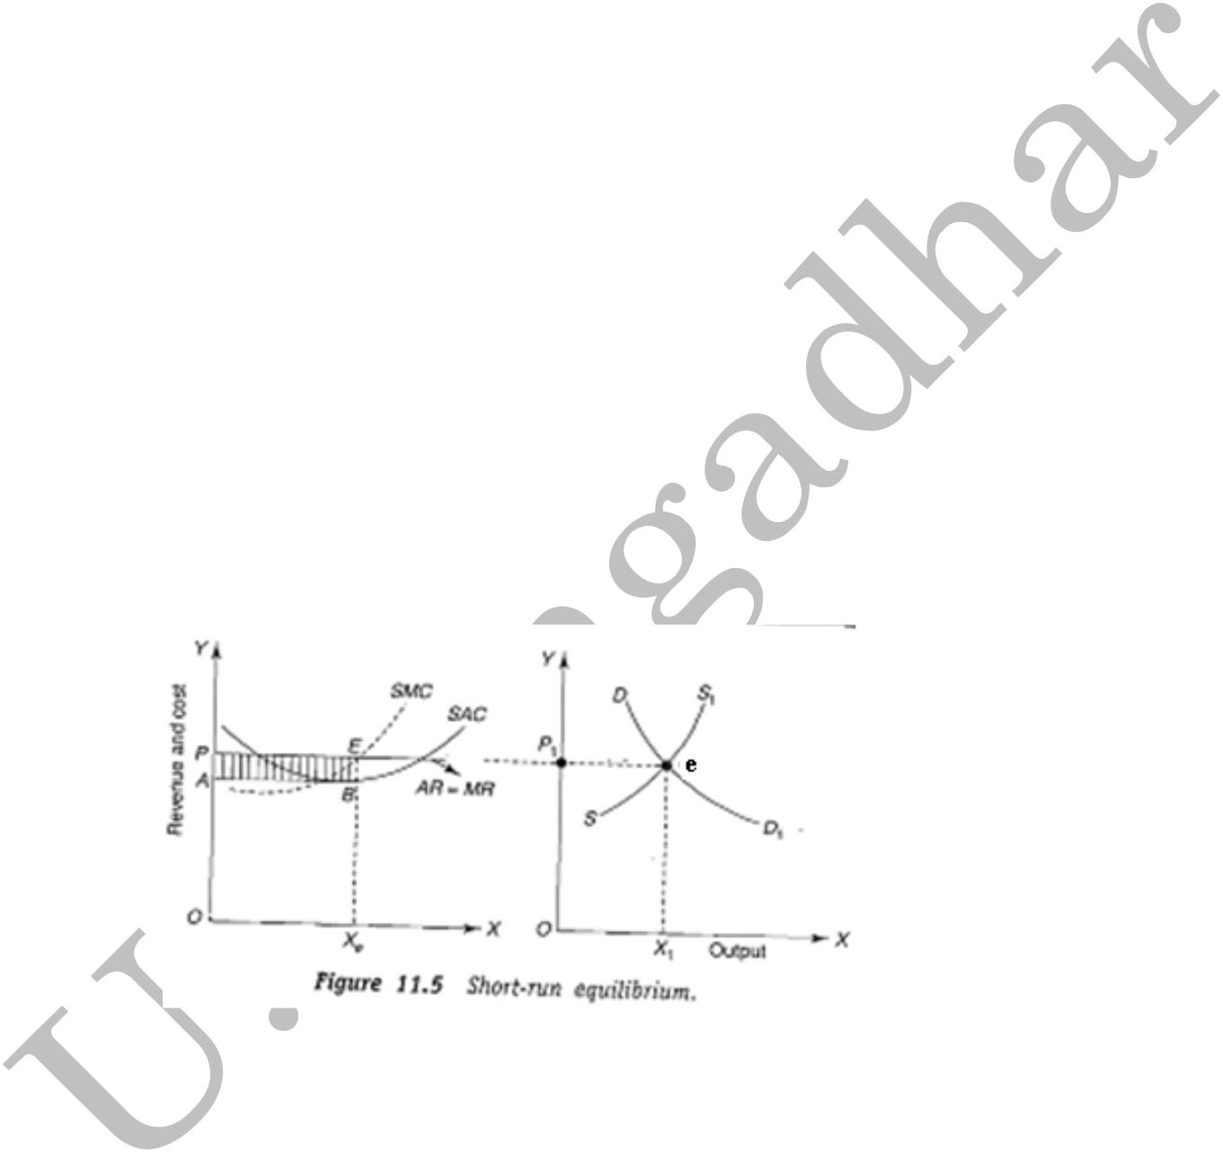

The firm‟s marginal revenue curve is horizontal at the price determined in the industry (MR=AR=Price). This curve is also known as average revenue curve.

When the average revenue is constant, it will coincide with the marginal revenue curve. Thus CC curve representing the price, average revenue curve, and also the marginal revenue curve (MR=AR=Price).Curves SAC, SMC represents firm‟s short-run average cost and short-run marginal cost respectively.

In the above diagram the firm satisfies both conditions: i) MR=MC; and ii) MC curve must cut the MR curve from below. The firm attains equilibrium at point E where MR=MC.

In the Long-run:

In the long run new firms enter into the industry, because, they are attracted by high profits. So, there will be a huge demand for scarce inputs among the competing firms pushing the input prices. Hence, the average cost increases. The entry of more firms will expand the supply pulling down the market price. As a result, in the long-run firms will be in a position to enjoy only normal profits. The long-run equilibrium of a firm can be observed from the following diagram.

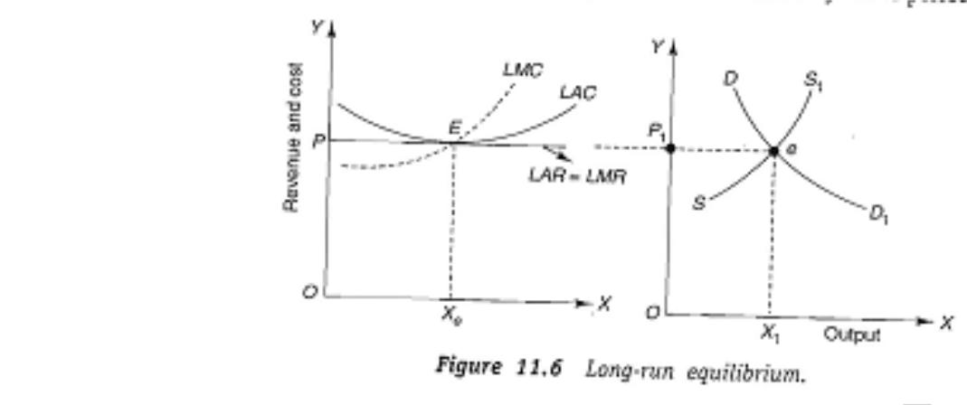

From the above diagram, it is to be observed that at OP price the firm‟s LMC curve is intersecting the MR curve from below at point „E‟. „OX‟ is the equilibrium output. At the equilibrium level the firm‟s AR is equal to „EX‟ and the LAC is also equal to „EX‟. Since LAC equals AR the firm is neither getting abnormal profits not suffering losses. The firm is only getting normal profits. The long-run equilibrium conditions are:

- MC is equal to MR.

- MC must cut MR from below.

- AR must be equal to minimum AC.

Thus in the long-run P=AR=MR=MC.

___________________________________

IMPERFEC T COMPETITION
B) IMPEPFECT COMPETITION MARKET

If there are imperfections in the market conditions, it is known as imperfect market that i.e. no single price, no equal number of buyers and sellers, etc. Ex: Monopoly, Monopolistic competition, oligopoly and duopoly competition.

MONOPOLY
MONOPOLY

Q3. What is Monopoly? What are the features of Monopoly?

The word monopoly is derived from two words. They are ‘Mono’ and ‘Poly’. The word „Mono‟ means single and „Poly‟ means seller. Thus monopoly means single seller. In the monopoly market that single seller or single firm is called as monopolist.

Definition:

“Monopoly is a market structure in which a single firm sells a product and for which there is no close

substitute.”

- Features of monopoly: The following are the features of monopoly.

  - Single person or a firm: A single person or a firm controls the total supply of the commodity. There will be no competition for monopoly firm. The monopolist firm is the only firm in the whole industry.

  - No close substitute: The goods sold by the monopolist shall not have closely competition substitutes. Even if price of

monopoly product increase people will not go in far substitute. For example: If the price of electric bulb increase slightly, consumer will not go in for kerosene lamp.

  - Large Number of Buyers: Under monopoly, there may be a large number of buyers in the market who compete among themselves.

  - Price Maker: Since the monopolist controls the whole supply of a commodity, he is a price-maker, and then he can alter the price.

  - Supply and Price: The monopolist can fix either the supply or the price. He cannot fix both. If he charges a very high price, he can sell a small amount. If he wants to sell more, he has to charge a low price.

  - Downward Sloping Demand Curve: The demand curve (average revenue curve) of monopolist slopes downward from left to right. It means that he can sell more only by lowering price.

  - Restrictions to the entry of new firms: Under monopoly there are restrictions to the entry of new firms in to the industry. These restrictions may take the form of legal or natural restrictions.

Q4. What is Monopoly? Price and Output determination under Monopoly?

Ans:

The word monopoly is derived from two words. They are ‘Mono’ and ‘Poly’. The word „Mono‟ means single and „Poly‟ means seller. Thus monopoly means single seller.

Definition:

“Monopoly is a market structure in which a single firm sells a product and for which there is no close

substitute.”

- Features of monopoly:

  - Single person or a firm.

  - No close substitute.

  - Large number of Buyers.

  - Price Maker.

  - Supply and Price.

  - Downward Sloping Demand Curve.

  - Restrictions to the entry of new firms.

- Price and Output Determination under Monopoly:

Under monopoly, the average revenue curve for a firm is a downward sloping one. It is because, if the monopolist reduces the price of his product, the quantity demanded increases and vice versa. In monopoly, marginal revenue is less than the average revenue.

In the short-run:

The monopolist always wants to maximize his profits. To achieve maximum profits, it is necessary that the marginal revenue should be more than the marginal cost.

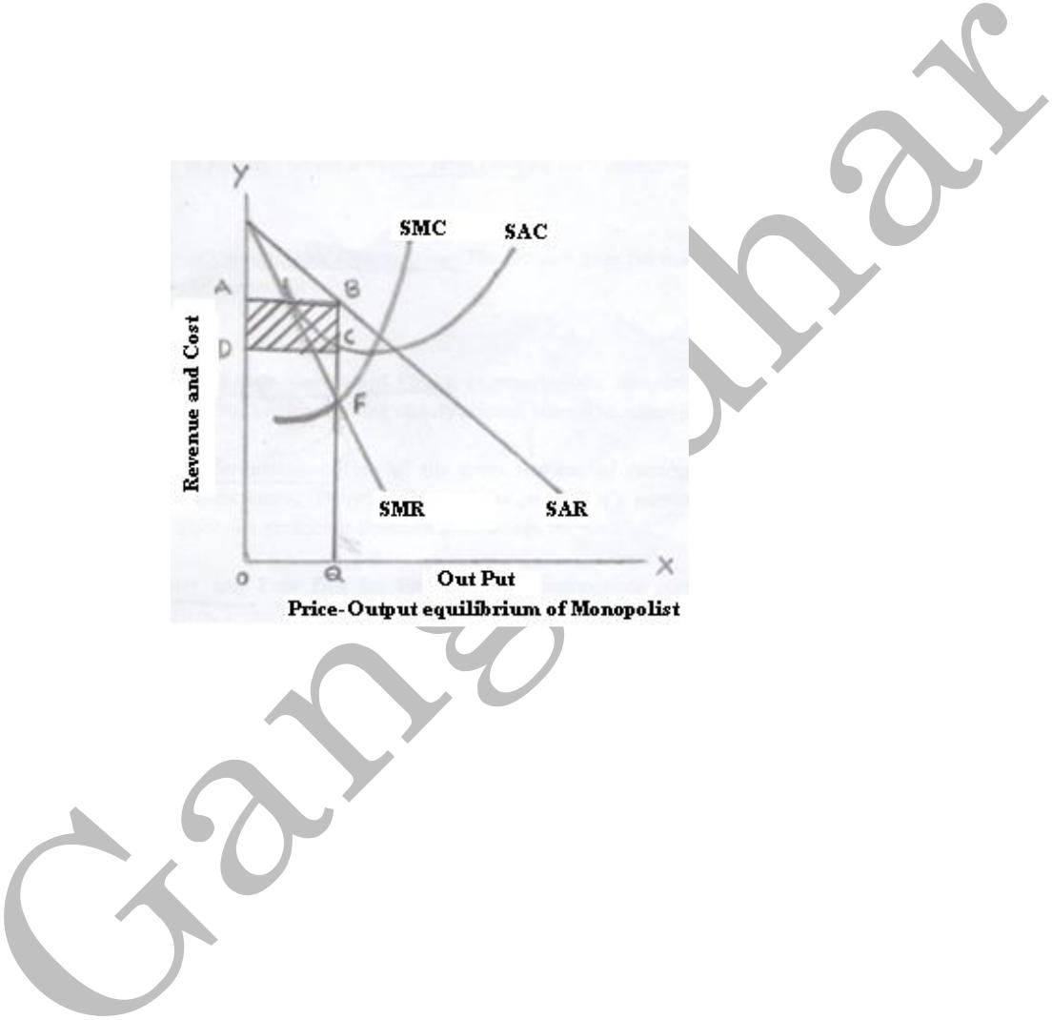
He can continue to sell as long as the marginal revenue exceeds marginal cost. At the point F, where MR=MC, profits will be maximized. Profits will diminish if the production is continued beyond this point. It can be shown in the following figure:

In the above figure we can see that the demand curve or average revenue curve is represented by SAR, marginal revenue curve is represented by SMR, average cost by SAC, and marginal cost curve by SMC. OQ is the equilibrium output, OA is the equilibrium price, QC is the average cost, and BC is the average profit.

Up to OQ output, MR is greater than MC and beyond OQ, MR is less than MC. Therefore, monopolist will be in equilibrium at output OQ where MR=MC and profits are maximum. OA is the corresponding price to the output level of OQ. The rectangle ABCD represents the profits earned by the monopolist in the equilibrium position in the short-run.

In the Long-run:

Under Monopoly, the monopolist continues to earn excess profits even in the long-run since the entry of new firms is not possible for institutional or technical reasons like huge finance, secret production techniques, etc.

In the long-run, the monopoly firm enjoys equilibrium at that level of output where the long-run MC equals long-run MR. The long-rung monopoly equilibrium can be illustrated in the following figure:




In the figure, the monopoly price RM (or OP) is greater than the average cost SM. The excess profit per unit is RS and total monopoly profit is shown by the shaded area PRST.

MONOPOLISTIC COMPETITION

Q5. What is Monopolistic Competition? What are the features of Monopolistic Competition?

Ans:

The concept Monopolistic competition was developed by Edward.H.Chamberlain. According to him monopolistic competition means “a large number of firms produce somewhat different products which are close substitutes of each other.”
- Features of Monopolistic Competition: The following are the main features of monopolistic competition.

  - Existence of Large Number of Firms: In monopolistic competition must have a large number of sellers or firms selling closely related, but not identical products.

  - Product Differentiation: One of the main features of monopolistic competition is product differentiation. There are many firms producing a particular product, but each firm introduces its product as different from others.

  - Free Entry and Free Exit for Firms: Under monopolistic competition, there are no entry barriers. Firms can enter or exit freely from industry.

  - Selling Cost: Since the products are close substitute much effort is needed to retain the existing consumers and to create new demand. So each firm has to spend a lot on selling cost, which includes cost on advertising and other sale promotion activities.

  - Large Number of Buyers: There are a large number of buyers in this type of market. However each buyer has a preference for a specific brand of the product.

  - Close Substitutes: Under monopolistic markets firms produce goods that are close substitutes to each other‟s product.

Q6. Define Monopolistic Competition. How are the price and output determined under Monopolistic competition?

Ans:

The concept Monopolistic competition was developed by Edward.H.Chamberlain. According to him monopolistic competition means “a large number of firms produce somewhat different products which are close substitutes of each other.”
- Features of Monopolistic Competition: The following are the main features of monopolistic competition.

  - Existence of Large Number of Firms

  - Product Differentiation

  - Free Entry and Free Exit for Firms

  - Selling Cost

  - Large Number of Buyers

  - Close Substitutes

- Price and Output Determination under Monopolistic Competition:

In the Short-run:

In the short-run, under conditions of monopolistic competition, every seller is interested in maximizing his profits. The profits are maximized where marginal revenue (MR) is equal to marginal cost (MC) of production. The following figures illustrate the profit and loss situations facing a firm under monopolistic competition in the short-run:

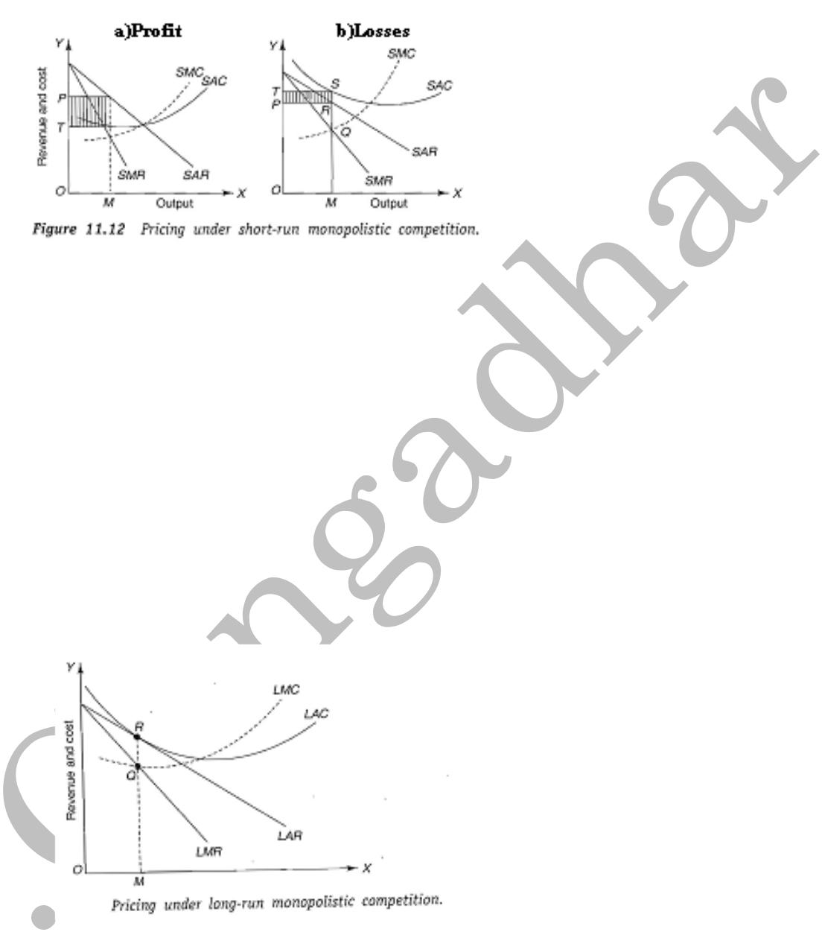

In the above figures, SAR and SMR are the short-run average revenue and short-run marginal revenue curves respectively. SAC and SMC are the short-run average cost and short-rum marginal cost curves respectively. The MC curve intersects the MR curve at the output OM in both figures (a and b). Therefore, OM is the equilibrium level of output.

At the equilibrium output OM, price is RM. The firm, shown under figure „a‟, is making an abnormal profit shown by the shaded area PRST while the firm shown under figure „b‟ is incurring a minimum loss (TSRP).

In the long-run:

In the long-run, if the existing firms are making abnormal profits, many new firms would be attracted to come in and join the industry. This would increase the supply and thus reduce the price. The following figure illustrates the long-run equilibrium under the conditions of monopolistic competition:

The above figure shows, at the equilibrium output OM, the price and average cost both are equal to RM.

There are no abnormal profits. Hence OM is the output which shows long-run equilibrium.

In the long-run, profits are normal when average revenue (AR) is equal to average cost (AC). Hence the condition of long-run equilibrium under monopolistic competition is that MR should be equal to MC and the AR is equal to AC. In short, in the long-run MR=MC=AR=AC.

OLIGOPOLY

Q7. What is Oligopoly? What are the features of Oligopoly?

Ans:

The term „oligopoly‟ is derived from the two Greek words „oligos‟ meaning „a few‟ and „pollen” meaning „to

sell”.

Definition:

“Oligopoly is a market structure, in which a few large firms produce either homogeneous or differentiated products and which are close substitutes to each other.”

Simply Oligopoly means competition among a few firms. Oligopoly markets can be classified into two categories. They

are:

- Pure Oligopoly Market

- Differentiated Oligopoly Market

Pure Oligopoly: In this market firms producing homogeneous product.

Differentiated Oligopoly: In this market firms producing differenced products, which are close substitutes of each other.

- Features of Oligopoly:

- Existence of Few Sellers: There is small number of large sellers supplying either homogeneous products or differentiated products.

- Homogeneous or Distinctive Product: The oligopoly firm may be selling either homogeneous product like steel or distinctive product like automobile-passenger cars.

- Blockaded Entry and Exit: Firms in the oligopoly market face strong restrictions on entry or exit.

- Imperfect Dissemination of Information: Detailed market information relating to cost, price and product quality are usually not published.

- Interdependence: The firms have a high degree of interdependence in their business policies about fixing of price and output determination.

- Advertising: Advertising and selling costs have strategic importance to oligopoly firms. Each firm tries to attract consumers towards its product by incurring excessive expenditure on advertising.

- Price Rigidity: In an oligopolistic market, each firm sticks to its own price. This is because; it is in constant fear of relation from rivals if it reduces the price.

DUOPOLY

Q8. What is Duopoly? What are the features of Duopoly?

Ans:

“Duopoly is a market structure, in which there are only two firms produce somewhat different products or homogeneous products and which are close substitutes to each other”.

- Features of Duopoly:

- Two sellers or firms: In the duopoly market only two sellers or firms are existed in the market.

- Large number of buyers: : Under duopoly, there may be a large number of buyers in the market.

- Homogeneous or Distinctive Product: It is may be two types: duopoly without product differentiation and with product differentiation.

- Close Substitutes: Under duopoly markets firms produce goods that are close substitutes to each other‟s product.

PRICING POLICIES
PRICING POLICIES

Q9. What are the Various Pricing Methods?

Pricing strategies/methods will depend on the pricing objectives of the company. The strategy must be suitable for achieving the desired objectives. Generally, the following are the pricing objectives:

- To maximize profits

- To increase sales

- To increase the market share

- To satisfy customers and

- To meet the competition.

Pricing methods:
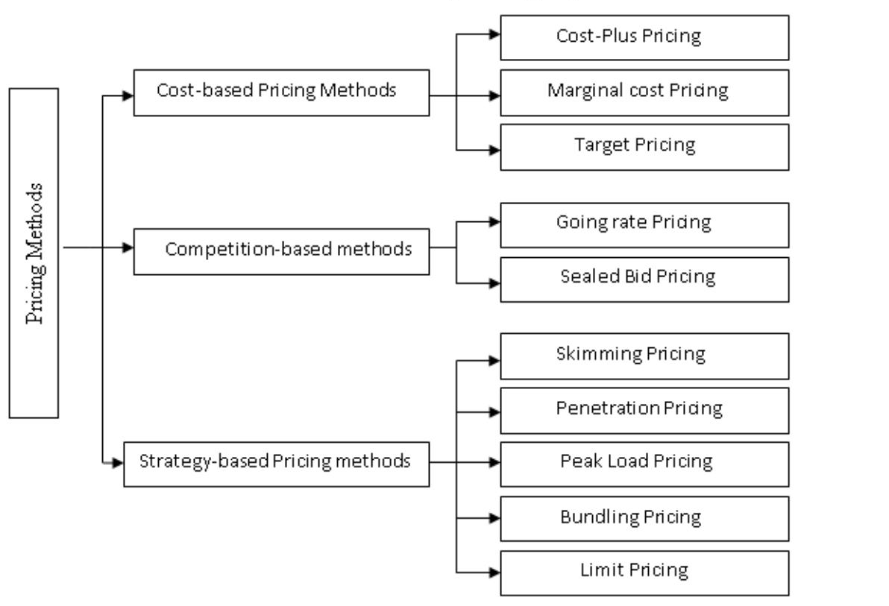

A. COST-BASED PRICING METHODS:

- Cost-Plus Pricing Method: This is also called full-cost or mark-up pricing. Under this method, required margin adds to production cost by using the following formula.
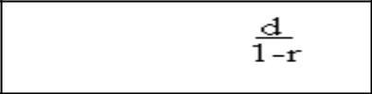

Mark-up Price=

Where,

d=cost per unit (both fixed & variable)

r=required rate of return.

- Marginal Cost Pricing: Marginal cost means additional cost to produce an additional unit of product. In this method price of a product determined on the basis of marginal cost or variable cost. Fixed costs are totally ignored.

  - Target Pricing: In this method, the manufacturer considers a pre-determined target rate of return on capital invested. The following formula is used to calculate the desired rate of return.

B. COMPETITION BASED PRICING METHODS:

- Going rate Pricing: In this method firms adopt a price ruling in the market rather than independently determining the price on their own.

- Sealed Bid Pricing: This method is more popular in tenders and contracts. To win a contract firm quotes less than the competitors in a sealed cover.

C. STRATEGY BASED PRICING METHODS:

- Skimming Pricing: When the product is introduced for the first time in the market, the company follows this method. In this method, the companies launching the new product at a higher price. There are two ways of skimming. They are:

- Rapid skimming Strategy: In this method the marketers launch the new product at a high price and high promotion strategies.

- Slow skimming Strategy: : In this method the marketers launch the new product at a high price and low promotion strategies.

- Penetration Pricing: This is exactly opposite to the market skimming method. In this method, the companies launching the new product at a low price. There are two ways of penetration.

- Rapid Penetration Strategy: In this method the marketers launch the new product at a low price and high promotion strategies.

- Slow Penetration Strategy: In this method the marketers launch the new product at a low price and low promotion strategies.

- Peak Load Pricing: In this method firms fix higher price during the peak times and low prices in the off-peak times.

- Bundling Pricing: It refers to the practice of bundling two or more different products together and selling them at a single
„bundle price.
- Limit Pricing: In this method a monopoly firm or oligopoly firms determines prices by collusion in such a way that they do not allow the entry or survival of new competitors.

INTERNET PRICING POLICIES

Q10. What are The Internet Pricing Models?

The most challenging job to the internet service providers(ISPs) is to adopt a most appropriate pricing strategy.
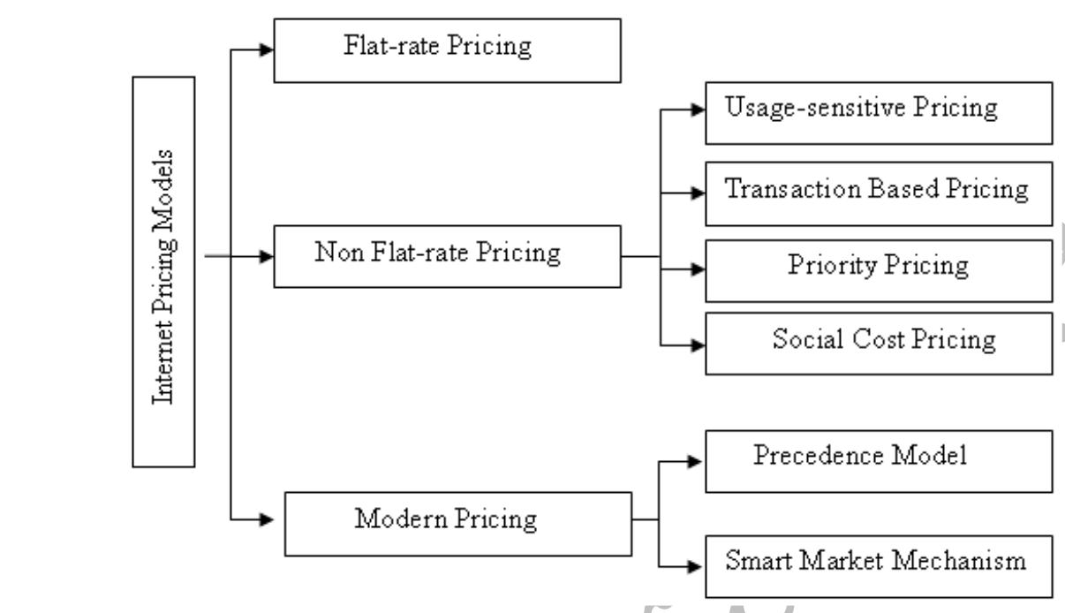
The following are the basic internet pricing access pricing models practiced by various ISPs.

- Flat-rate Pricing: In this method, a flat fee for a certain period of time. The user does not pay for any additional amount for usage on any new applications.

- Non Flat-rate Pricing: This pricing is further divided into following types:

- Usage-sensitive Pricing: In this model the fee paid by the user is divided in to two portions. The first portion of the fee is for the connection and the second portion of fee is for the usage of each bit sent or received.

- Transaction Based Pricing: Like usage sensitive pricing in this model also first portion of fee is for connection and the second portion of fee is charged on the characteristics of transaction not by the volume of bits sent/ received.

iii)Priority Pricing: In this model the user choose the quality of services that they want and pay a fee for the same. Users can priories their sending or receiving packets. This pricing allows the ISPs to charge more for important items by depends on the paying capacity of users.

iv)Social Cost Pricing: It is similar to peak load pricing. In this method the ISPs charge the amount on the basis of social cost by differentiating rural and urban areas.

- Modern Pricing: This pricing is further divided into following types:

- Precedence Model: In this model a process is set to prioritize the different applications in the precedence field of the different data packets.

- Smart Market Mechanism Model: By depends on the level of network congestion, the price of sending a packet varies from minute to minute. Each packet has a bid field in its header. Users indicate their maximum willingness to pay for processing each packet. Higher bided packets processed earlier than the lower bided packets in the event of congestion.

Marris Managerial Theory of the Firm

Q.11) Explain in detail about Marri’s growth maximization model.

Ans:

According to Marri's, owners/shareholders strive for attaining profits and market share and managers strive for better salary, job security and growth. These two objectives can be attained by maximizing the balanced growth of the firm. The balanced growth of the firm relies mainly on the growth rate of demand for the firm‟s products and growth rate of capital supplied to the firm. If the demand for the firm‟s product and the capital supplied to the firm grows at the same rate then the growth rate of the firm will be considered as balanced.

Maris found that the firms face two difficulties while attaining the objectives of maximization of balanced growth which are managerial difficulties and financial difficulties.

Managerial difficulties occur because of the inability of the managers to administer and attain optimum efficiency and the job security of the managers. The financial difficulties occur because of the difference that exists among the utility function of the managers which they try to attain for maximizing the utility function of the owner.

According to Marri‟s, the growth rate of the firm is:

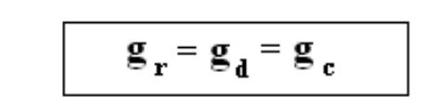

Where,

gr= balanced growth rate.

gd= growth of demand for the firms products and .

gc= growth of supply of capital.

Marris has given the managerial utility (Um) and owner‟s utility functions as:

- Manager‟s utility function (Um) = f (salary, power, status, job security).

- Owner‟s utility function (Uo) = f (profit, capital, output, market share, public esteem).

Marris stated that the maximization of these variables help the managers to optimize their own utility function as well as their owner‟s utility function. This is possible as the majority of the variables occurring in the manager‟s utility function such as salaries, status, job security, power etc., and the variables occurring in the owner‟s utility function such as profit capital, market share etc., are associated with a single variable-size of the firm. The maximization or optimizations of these variables rely on the growth rate maximization of the firms. So the firms try to maximize a “constant or steady growth rate”.

The constant or steady growth rate was defined by Marris with regard to two different variables. For managers it was defined with respect to the growth in demand for the products of the firm (gd) and for owners it was defined with respect to the growth of the capital of the firm (g). Hence, Marris reformed the manager‟s utility function and owner‟s utility function as:

Um = f (gd)

Uo = f (gc)

Marris stated that the managers seeks to maximize their utility function in such a manner that gd = gc (which is the balanced growth rate), the firm attains equilibrium if the balanced growth rate is attained. The main aim of the managers is to optimize the balanced growth rate so that the gd = gc.

The firm will be in equilibrium if,
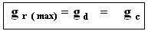

gd and gc reformulated by Marris as:

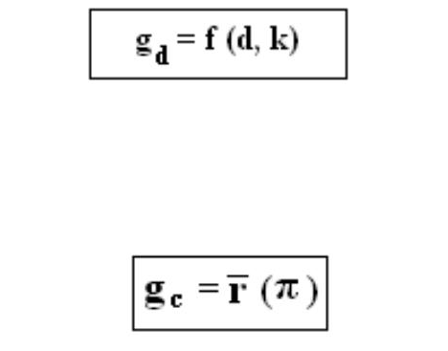

Where,

d= product diversification and

k= rate of success of new products. And

Where,

= ratio of financial security which is assumed as a uniform proportion of profit (π).

Marris model assumes that the managers ascertain intuitively.

WILLIAMS M ANAGERIAL THEORY OF FIRM
Williamson’s Managerial Theory of the Firm

Q12). Explain in detail about the Williamson’s managerial theory of the firm.

A full-fledged managerial theory of the firm has been put forward by O.E. Williamson who emphasizes that managers are motivated by self-interest and they maximize their own utility function.

According to Williamson, utility function of the self-seeking managers depends on the following factors. They

are:

- Salary and other forms of monetary compensation: According to the Williamson, salary and other monetary compensation are not the total reward received by the managers‟ from their firms and also these are not the only factor determining the utility of the managers.

- Number of Staff under the Control of a manager: The greater the number of staff under the control of a manager, the greater the status and prestige of a manager and also the greater the power wielded by him.

- Management Slack: This consists of those non-essential management prerequisites such as company cars, furniture offices etc which are not necessary for effective operation of a firm. The management slack also enters into the cost of production of a firm.

- Magnitude of Discretionary investment Expenditure by the Manager: This refers to the amount of resources which manager can spend according to his discretion.

Managerial Utility Maximization: Williamson clubs the first two variables. They are:

- Salary and other monetary compensation received by the manager.

- Number of staff under his control in to a single variable.

Utility of manager in his model is a function of the following three variables.

U = f (S, M, Id,)

Where,

U = Utility Function

f = dependence on

S = Salary & Monetary Expenditure on Staff

M = Management Slack

Id= Amount of Discretionary investment.

Concepts of Actual discretionary and Reported Profits: Williamson identified three concepts of Profits. They are:

- Actual Profits: These are the difference between total revenue earned less the production costs and expenditure on staff.

- Reported Profits: It is the difference between actual profits and nonessential managerial expenditure as represented by management slack.

- Minimum Profits: These are the amount of profits (after tax) which are required to be paid as acceptable dividends to satisfy the shareholders who are the owners of the firm.

QUIZ
1. Exchange value of a unit of good expressed in terms of money is called ( )
(a) Cost (b) Capital
(c) Price (d) Expenditure
2. The price of a product is determined by the ______of that product ( )
(a) Place and time (b) Production and sales
(c) Demand and supply (d) Cost and income
3. The price at which demand and supply of a commodity equal is ( )
Known as
(a) High price (b) Low price
(c) Equilibrium price (d) Marginal price
4. A market where large number of buyers and sellers dealing in homogeneous product with perfect knowledge is called ( )
(a)Imperfect competition (b) Monopoly
(c) Perfect competition (d) Monopolistic competition
5. In which market, single market price prevails for the commodity ( )
(a) Monopoly market (b) Oligopoly market
(c) Perfect competition market (d) Duopoly market
6. The Price determined in the very short period is known as_____. ( )
(a) Secular price (b) Normal price
(c) Market price (d) Short run price
7. In which period, the supply of commodity is fixed ( )

(a) Short period (b) Long period
(c) Very short period (d) Very long period
8. Charging very high price in the beginning and reducing it gradually is called ( )
(a) Differential pricing (b) Sealed bid pricing
(c) Skimming pricing (d) Penetration pricing
9. If monopoly arises on account of legal support or as a matter of legal Privilege, it is called as ( )
(a) Private monopoly (b) Government monopoly
(c) Legal monopoly (d) Single price monopoly
10. Under which pricing method, price just equals the total cost ( )
(a) Marginal cost pricing (b) Cost plus pricing
(c) Full cost pricing (d) Going rate pricing
11. ______ is a place in which goods and services are bought and sold. ( )
(a) Factory (b) Workshop
(c) Market (d) Warehouse
12. ___________________ is the example for perishable goods. ( )
(a) Pens (b) Belts
(c) Vegetables (d) Cloths
13. ____is a form of market organization in which there is only one seller of the commodity. ( )
(a) Perfect Competition (b) Duopoly
(c) Monopoly (d) Oligopoly
14. If average Revenue is greater than the Average cost, monopolist earns ( )
(a) Loss (b) No loss No profit
(c) Profit (d) None
15. The firm is said to be in equilibrium, when it‟s Marginal Cost (MC) equals to___ . ( )
(a) Total cost (b) Total revenue
(c) Marginal Revenue (d) Average Revenue
16. _______ is a position where the firm has no incentive either to expand or contrast its output ( )
(a) Maximum output (b) Minimum output
(c) Equilibrium (d) None
17. Marginal revenue, Average revenue and Demand are the same in ________ Market Environment ( )
(a) Monopoly (b) Duopoly
(c) Perfect Competition (d) Imperfect Competition
18. ___ is a period in which supply can be increased by altering the Variable factors and fixed costs will remain constant. ( )
(a) Long – run (b) Mid – term
(c) Short – run (d) Market period
19. The total supply of a good is produced by a single private person or firm is called as________. ( )
(a) Government Monopoly (b) Legal Monopoly
(c) Private Monopoly (d) Natural Monopoly
20. In perfect competition market, seller is the _________. ( )
(a) Price – Maker (b) Price changer
(c) Price – Taker (d) Price Dictator
21. Charging Very Low price in the beginning and increasing it gradually is called ________ ( )
(a) Differential pricing (b) Sealed bid Pricing
(c) Penetration Pricing (d) Skimming Pricing
22. If Average Revenue is less than the Average Cost, Monopoly secures __. ( )
(a) Profits (b) Abnormal Profits
(c) Losses (d) Super Profits
23. In Monopoly market environment, seller is the __________. ( )
(a) Price - Taker (b) Price – Accepter
(c) Price - Maker (d) None

UNIT-III Imp Questions

Essay Questions:

- a) Define Market and explain how markets are classified?

  - What are the important features in Market structure?

- a) What is perfect competition? What are its features?

  - How is market price determined under conditions of Perfect Market Competition?

- a) Explain in detail, the important features of perfect competition

  - How can a competitor attain equation position under conditions of perfect competition?

- Define Monopoly? How are price and output determined under monopoly?

5. Define Monopolistic Competition. How are the price and output determined under Monopolistic competition?

- Discuss the Marri‟s Managerial Theory of firm.

- Explain the significance of Williamson‟s managerial theory of firm

- Explain the various pricing methods.

- What are the various internet pricing methods?

Short Answers:

- Perfect competition

- Monopoly

- Monopolistic competition

- Oligopoly

- Duopoly

- Limit pricing

- Skimming

- Penetration

